## **Template 1: My Favourite Teacher:**

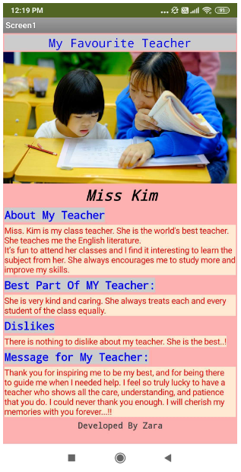

## **Template 2: My Parents:**

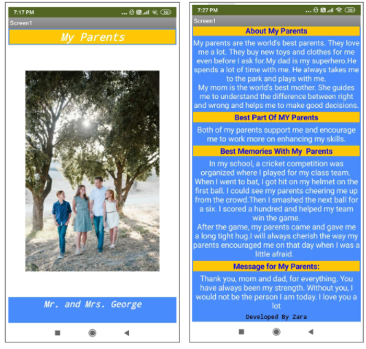

## **Template 3: My Best Friend:**

